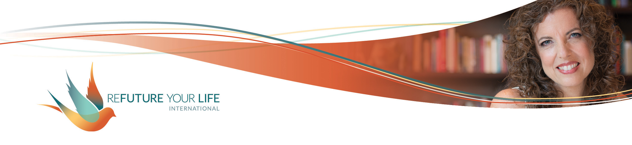

Embracing Your Inner Bad Girl

Much of what we do in this group could be categorized as Shadow Work – finding what’s been hidden, censored and pushed away, and bringing it back into the wholeness of who we are. This month, we’re focusing this process on our inner Bad Girl (or Bad One if you prefer).

There’s a saying that “A god(dess) ignored is a demon(ness) born”. This is because anything we push away can become distorted, even monstrous. That which we bring in to our wholeness can find its rightful place and share its gifts.

Being raised as girls in this society, we all internalized some degree of the Good Girl conditioning. [If you didn’t, you’re a rare exception.] Having a Good Girl aspect isn’t a problem. She’s helped you get where you are and survive/thrive in a male-dominated culture.

The problem is anywhere you’ve become constricted by the Good Girl persona, the possibilities and authenticity this cuts off, the fear it engenders, and the ways it keeps you from living your fullest, richest life.

This month, we’re going to play with your inner Baddie and discover what gifts and powers they have to share with you.

**Honoring the Good Girl**

We’re going to start by honoring your inner Good Girl and how this part of you has served you. We’re not relegating her to the shadows either.

*How has your inner Good Girl/Good One served you?*

______________________________________________________________________

______________________________________________________________________

______________________________________________________________________

______________________________________________________________________

______________________________________________________________________

*What would you miss about her if she disappeared?*

______________________________________________________________________

______________________________________________________________________

______________________________________________________________________

______________________________________________________________________

*What are you grateful to her for?*

______________________________________________________________________

______________________________________________________________________

______________________________________________________________________

______________________________________________________________________

Now, lovingly ask your Good Girl to step to the side so the Bad Girl can come forward.

**Honoring the Bad Girl**

What do you notice in your body when you think about honoring the Bad Girl? What does the thought of the Bad Girl bring up?

Whenever I see something that “the powers that be” have declared as taboo, I get excited. It’s a sign that there’s power in that thing. Think about. Right now, there are taboos in our society around sexuality, women’s bodies, bodies of color, bodies of gender non-conforming individuals, conversations about race, women’s rights to their bodies and decisions.

Each of these speaks to the power of the individual, the power of the true freedom to be different and oneself, the power of coming together as equally honored individuals. They speak to deeper levels of love and acceptance.

In the past, I might have said that this goes against tribal mentality, the safety of the group. Recently, though, I read an article highlighting that that’s a very white perspective. Most native tribes honored individualism, two-spirit people, etc.

Now, I see intolerance for difference as a response to trauma and unaddressed wounds, and above all, fear. (Why this is so prevalent in the dominant white culture is beyond the scope of what I’m addressing here, and I do acknowledge this truth.)

If you’d like, take a deep breath and shake your body. You get to focus on yourself here.

The Bad Girl is the often the holder of deep desires, deep truths, and a passion for justice. The Bad Girl is one of our greatest healers. You don’t have to become her, and you don’t have to do everything she would like you to. Because she’s been shunned for so long, some integration and scrubbing down may be needed to get to her real jewels. That’s what we’re doing this month.

Your Bad Girl shines when you have a need not being met, or when you’re constricted by your Good Girl conditioning. Working intentionally with her often shows us what we truly care about, need and want, and is the catalyst for going after them.

As we invite your Bad Girl to come play, it’s important to know that no one will ask you to follow through on your Bad Girl desires. It may be that not all of you even wants these things. The important thing is to let them come up and be seen.

The invitation is to be *more* greedy, *more* demanding and *more* self-centered. How outrageous can you let your Bad Girl be?

Are you ready to explore and play?

*What do you notice when you contemplate embracing your inner Bad Girl?*

______________________________________________________________________

______________________________________________________________________

______________________________________________________________________

*Where in your body to you feel her/them?*

______________________________________________________________________

______________________________________________________________________

*What does she like to be called?*

______________________________________________________________________

*What does your Bad Girl like to eat, wear, do?*

______________________________________________________________________

______________________________________________________________________

______________________________________________________________________

______________________________________________________________________

______________________________________________________________________

______________________________________________________________________

______________________________________________________________________

______________________________________________________________________

______________________________________________________________________

*Set a timer for 5 minutes. Write as many things as you can starting with the phrase, “If I were a Bad Girl, I’d…”. If you get on a roll, write as long as you want to. Being a Bad Girl and doing this exercise your way is welcomed. 😊*

______________________________________________________________________

______________________________________________________________________

______________________________________________________________________

______________________________________________________________________

______________________________________________________________________

______________________________________________________________________

______________________________________________________________________

______________________________________________________________________

______________________________________________________________________

______________________________________________________________________

______________________________________________________________________

______________________________________________________________________

______________________________________________________________________

______________________________________________________________________

______________________________________________________________________

______________________________________________________________________

______________________________________________________________________

______________________________________________________________________

______________________________________________________________________

*How was that? What do you notice?*

______________________________________________________________________

______________________________________________________________________

______________________________________________________________________

______________________________________________________________________

If you found anger or violence showing up, I invite you to honor it. Keep going. Can you be even more greedy and demanding?