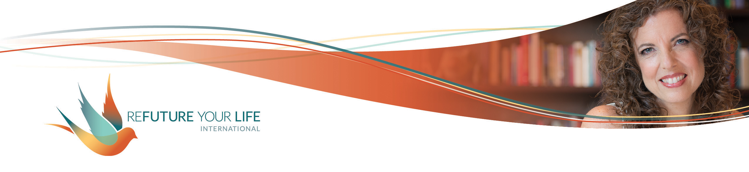

Expanding Your Power with Money

Money. What a challenging topic for the vast majority of people! In this world where emotional, mental and physical wounds are common and trauma is tragically common, it’s not surprising.

Money is an interesting combination of:

* universal energy, without which none of this would exist
* the “real world”, without which money wouldn’t exist
* numbers, without which we couldn’t track money

Let’s pause here and take an inventory:

*What do you think, feel and sense in your body when you put your attention on “universal energy”?*

________________________________________________________________

________________________________________________________________

________________________________________________________________

________________________________________________________________

*What do you think, feel and sense in your body when you put your attention on “the real world” or “society”?*

________________________________________________________________

________________________________________________________________

________________________________________________________________

________________________________________________________________

*What do you think, feel and sense in your body when you put your attention on “numbers”?*

________________________________________________________________

________________________________________________________________

________________________________________________________________

________________________________________________________________

We’ll work with this on our call. For now, take a few deep breaths. Come back when you’re ready.

There’s a strong connection between what we can give and what we can receive. While we may be far more comfortable with one than the other, expanding our capacity with one will also expand our capacity with the other. At a minimum, it shifts the energy of the other.

For example, it may be easier for you to give then to receive, but if you can’t receive, you can’t give as freely as you’d like. At some point, your generosity begins to constrict out of necessity or fear or running out, whether you’re giving money, energy or emotional support.

When you’re able to receive more, you have more to give. You also feel more easeful in the giving, knowing that you have what you need. [This is why I encourage you to give from your overflow rather than from your own cup.]

There’s also a strong connection between showing up in the world and how much you receive. Showing up doesn’t necessarily mean posting on social media. The more you show up with your clients, the more you receive. The more you show up in the world – whether it’s on social media, at networking events, through a book, whatever – the more engagement you have and the more you receive.

Contractions in your mind, body, heart and energy slow the flow. Contractions come from your S.T.U.F.F. (stuck thoughts, unprocessed feelings and fears). What’s even more relevant is that contraction comes from your *resistance* to your thoughts, feelings and sensations, including your S.T.U.F.F. This is a bit more advanced understanding, and something we’ve been working on for quite some time.

**Acceptance is the key**

It's not just that you have a fear, for example, but judging that fear as bad and wrong makes the constriction even tighter. Realizing that all of your fears, thoughts and feelings began out of a desire for self-protection and survival makes it easier to accept them. Even the beliefs that create systemic oppression and that value power over others came from traumas in past generations.

This doesn’t mean that you need to keep them. It does mean that you need to update your nervous system and any parts of you holding onto them. The more you can let yourself know that you’re safe and okay, and that things can change – and often have already – the more you can relax. The more relaxed you are, the more you’re able to do things differently. The more relaxed you are, the more expansive you are.

Let’s play with this a bit.

*What’s a situation regarding money, income, or showing up that you don’t like or accept?*

______________________________________________________________________

______________________________________________________________________

______________________________________________________________________

*What do you feel in your body as you put your attention on that situation?*

______________________________________________________________________

______________________________________________________________________

*What are you afraid of? Write as much as you can for this, whatever comes to mind.*

______________________________________________________________________

______________________________________________________________________

______________________________________________________________________

______________________________________________________________________

______________________________________________________________________

______________________________________________________________________

______________________________________________________________________

______________________________________________________________________

______________________________________________________________________

*What could happen if you fully accepted the situation and the* ***possibility*** *that there’s nothing wrong with it? Write as much as you can for this. Let your mind go free with it.*

______________________________________________________________________

______________________________________________________________________

______________________________________________________________________

______________________________________________________________________

______________________________________________________________________

______________________________________________________________________

______________________________________________________________________

______________________________________________________________________

______________________________________________________________________

*How was that? Did anything surprise you?*

______________________________________________________________________

______________________________________________________________________

______________________________________________________________________

______________________________________________________________________

*List* ***at least*** *8 accomplishments related to money. These can be from the present or the past. Nothing is too small. List as many as you can think of. If more occur to you later, add them in. This is an evidence list that we’ll be using on the call.*

1. ________________________________________________________________
2. ________________________________________________________________
3. ________________________________________________________________
4. ________________________________________________________________
5. ________________________________________________________________
6. ________________________________________________________________
7. ________________________________________________________________
8. ________________________________________________________________
9. ________________________________________________________________
10. ________________________________________________________________
11. ________________________________________________________________
12. ________________________________________________________________
13. ________________________________________________________________
14. ________________________________________________________________
15. ________________________________________________________________