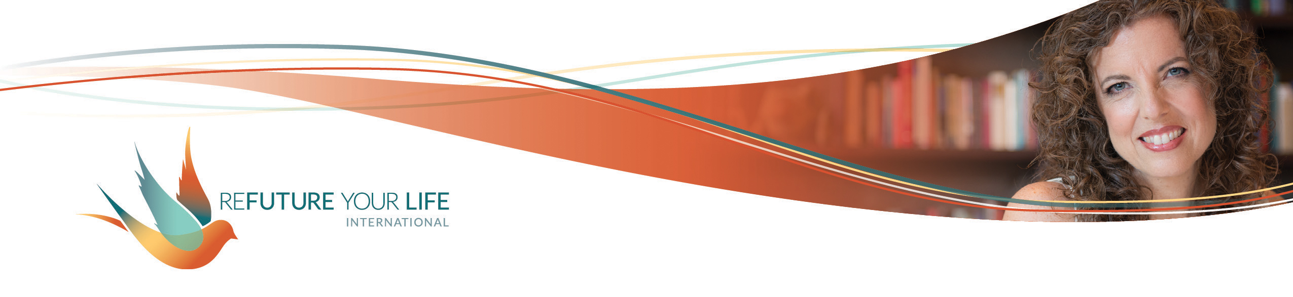

Embracing the Mess

Several years ago, I was at a leadership retreat. The facilitator had us assign two words to each person in the group, indicating how we wanted them to stretch in order to be more effective leaders (and humans). One person was asked to try on being subtle, while another was asked to be raucous.

My two words were “bold” and “awkward”. “Bold” was uncomfortable, but understandable. Boldness in a leader is a real asset. But who in hell wants to be awkward?? Why was that even a goal?? How could that expand me as a leader? Who wants an awkward leader?

No one liked their words because they pushed us out of our comfort zones big time. And we had to practice embodying them for the entire retreat. We even had to perform a song while embodying at least one of our words. Seriously? Nooooooo…!!!

As much as I resisted it at first, it was an incredible experience for me. I learned that I couldn’t be bold without being willing to risk being awkward. Not every experience of being bold led to my being awkward, but it was always a possibility. And every time I aimed for being awkward, I was also being bold.

The biggest learning though was how much fun I had. It was incredibly freeing and fulfilling to live this bigger version of myself. I did things like performed a chair dance in front of the group, stepped in to guide and support someone who had a spiritual breakdown/breakthrough, and asked things of people that built deeper connection between us. I was so much more of **me**.

Most everyone had a similar experience with their words. Even though I was the only one with the word “awkward”, everyone felt awkward as they practiced their words. But when we stepped out of our comfort zones and risked being messy and making mistakes, we ended up having more tears, more laughter and richer connections.

Being human is a glorious, messy, painful, joyful, heartbreaking, amazing experience that we’ll only have once in these bodies. And we’re here to have the full range of this experience.

It’s so, so easy to hold ourselves back in big and small ways. To stay in our comfort zones, even when we’re comfortably miserable.

We do this by limiting ourselves to what feels good and pleasant, whether that’s emotions, thoughts or experiences. We stick with what we know, what we can do well and what we’re told is okay. We may even fear the unpleasant and the messy.

You are a unique soul with a unique way of being in this world. ***This means that you’re different. To live your full expression, you’re going to have to blaze your own trail. You’re going to have to do things differently from everyone around you.*** This is the opposite of one-size-fits-all.

The hardest thing about this is that every one of us is wired to need love and belonging. The imperfect, conditional love we’ve been shown by our very human family and friends has taught us that in order to belong, we need to fit in, look good, and do everything well.

But that’s the opposite of the truth.

If you’re not free to make mistakes and be messy, you’re not free to live the one-of-a-kind combination of specific dreams, hopes and desires that you are, to be the unique expression of Love/ Life/ God/ Source that you were created to be. And that sentences you to living an unfulfilling life.

You’re also not free to be authentic. If it’s not okay to be angry, hurt, sad, elated, playful – or those things aren’t as good as being happy, content, excited, pleased, etc. – then you’ll just keep showing up as…fine. Bland, gray, lukewarm, unfulfilling fine.

It’s simple – **in order to learn, grow and be creative to our fullest capacity, to have true freedom and full joy, we have to be able to risk making mistakes and creating a mess.**

If you have a very strong negative reaction to the thought of making mistakes, it’s likely that you experienced extreme consequences in the past for doing something “wrong”. That reaction is a trauma response of fleeing and/or freezing. If this is true for you, **be very gentle and compassionate with yourself**. **Do as much and as little of this process as feels right for you.**

Above all, **treat yourself with love**. To some extent, change can be made and steps can be taken by pushing and forcing. **True transformation and healing, though, only happen in the presence of love.** If “all” you do this month is love yourself a little bit more, I’ll be excited to celebrate that with you.

And remember, **making the mess is not the same thing as *being* a mess**. If you’ve been told that you’re a mess or are messy and it’s a tender point for you, try using the word awkward. Or simply notice what you feel and sense when you think of “mess”, and let that be enough for this round.

So what might a mess look like?

* Having a vulnerable conversation and the other person getting upset.
* Taking up a new hobby or sport that other people see you doing.
* Sharing something on social media that feels embarrassing.
* Pointing out someone’s hurtful remarks to them.
* Being the first to say, “I love you”, and not having it returned.

Before we move into the exploration, I’d like to share a quote with you. On The Man Enough podcast from Aug 2, 2021, the host, Justin Baldoni, referred to the guest, Alok Vaid-Menon, with the incorrect pronoun and apologized. I found Alok’s response profound, and very appropriate to this conversation.

***"Welcome to the awkward choreography of being a human. We're always going to mess up because we are indoctrinated into a world that teaches us ideology and not compassion....*** *Learning is the most delightful thing about being alive. When you mess up, that is when you're being alive, because being alive is about messing up gloriously. And I will fight for that ability to gloriously mess up because I don't believe that humans are statues or sculptures. I believe that we're inconsistent and idiosyncratic and hairy and fat and unfurling, and that's what's joyous about being alive.”*

***~*** https://www.alokvmenon.com/gallery/2021/8/2/kqofjed9cmohcx22089f0v3b2gnjts

**The invitation this month is to play with the possibility of being messy and awkward, maybe even having it as a goal.**

Ready to explore your relationship with creating a mess?

*What do you notice in your body when you think about making a mess of any kind – physical, metaphorical, emotional, relationship, etc.?*

______________________________________________________________________

______________________________________________________________________

______________________________________________________________________

______________________________________________________________________

______________________________________________________________________

*What would change if it were truly as okay for you to be upset as happy? Sad as glad? Frustrated as energized?*

______________________________________________________________________

______________________________________________________________________

______________________________________________________________________

______________________________________________________________________

______________________________________________________________________

*What would change if you were truly free to make mistakes and be messy and awkward?*

______________________________________________________________________

______________________________________________________________________

______________________________________________________________________

______________________________________________________________________

______________________________________________________________________

*Picture yourself as a young child. What kind of messes would have been great fun to make?*

______________________________________________________________________

______________________________________________________________________

______________________________________________________________________

______________________________________________________________________

______________________________________________________________________

*What kind of messes might be fun to make now?*

______________________________________________________________________

______________________________________________________________________

______________________________________________________________________

______________________________________________________________________

______________________________________________________________________

*What’s a mistake or mess that you made in the past? What’s come from it? Is there anything you still feel bad about or regret?*

______________________________________________________________________

______________________________________________________________________

______________________________________________________________________

______________________________________________________________________

______________________________________________________________________

***What’s the kindest thing you could tell yourself about that experience?***

______________________________________________________________________

______________________________________________________________________

______________________________________________________________________

______________________________________________________________________

______________________________________________________________________

*If you choose to make a goal this month of making messes and being awkward, what’s your target number? _________*

*What do you notice in your body as you sit with that?*

______________________________________________________________________

______________________________________________________________________

______________________________________________________________________

______________________________________________________________________

______________________________________________________________________