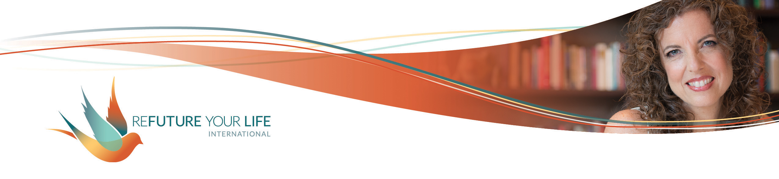

Who Do You Want to Be this Year?

Happy New Year!

There’s something very magical about beginnings. Whether you’re beginning a new year, month, week, day or project, starting it with intention will impact everything that follows. It’s the difference between starting out with all four wheels of your car pointing the same way, versus having one or two of them (or even all four) catawampus. You’ll build a lot more momentum and cover more distance with inner alignment.

That’s why so many people make resolutions, goals and/or intentions for the new year. I’m going to make some suggestions based on what I’ve experienced and what works for me. If something else works better for you, then by all means go with that. I’d love to hear about it. And I invite you to play with the ideas below.

**Any time you create an intention, it’s important to remember that you’re not doing this in order to control Life.** You can’t, even though it can be so tempting to try. Instead, practice holding your intention consistently and lightly. An intention is about us leading ourselves, and then dancing with whatever Life bring us.

If it helps, after stating your intention you can say, “**I ask for all of this or something better.**” And don’t get hooked on “better” meaning bigger or more, just more aligned for you. I like to have my hands open when I make intentions to remind myself I’m not clutching or grabbing, and I’m open to receiving.

It’s common to set goals or make resolutions for a new year. To me, “resolutions” feels heavy and judge-y. There’s a sense of fixing something that’s wrong, or doing better because who you were/are isn’t good enough. That’s a disempowering energy to start the year with.

Goals can be helpful, but they’re often focused on having and doing things, in other words, on things outside of you. It’s easy to miss the subtle “so that” underlying the choice of goals. For instance, “My goal is to lose 25 pounds (so that I like my body more)” or “My goal is to have a $100,000 year (so that I feel successful and worthy)”. As with resolutions, there’s an energy of fixing what’s “wrong” with us. Plus, getting things on the outside (money, recognition) is nice, but it won’t heal feelings of unhappiness or unworthiness.

Another option is to **start on the *inside* by asking yourself, “Who do I want to be in this new year?”**

Remember, though, that this isn’t about becoming someone you aren’t already. **Part of you is already exactly what you’re seeking to be.** If you want to be healthier in your body, there’s already a part of you that is radiantly healthy. Think about times when you were healthy, or were making healthier choices than you are now. That’s still inside you.

Let’s say you want to be more creative. Think about how creative you were as a kid. What are other ways you’ve shown your creativity? You not expressing it now doesn’t mean it’s not still there. It is!

It’s the same with wanting to be organized, loving, truthful, courageous and anything else. Part of you already is this and knows how to do it. It’s a question of focusing your attention on it and expanding your capacity to express this quality – and loving whatever limitations you’ve put on yourself until now.

This isn’t about becoming someone or something new. There’s nothing wrong with who and how you are now! **This is about *experience* – what you want to experience and how you want to experience yourself being in the year ahead.** What might this open up for you?

If you’re used to setting goals for the year, that’s great! Knowing what you want to do and have can be extremely useful. Acknowledging that you want something is powerful, especially if you’ve gotten messages that it’s not okay for you to have desires. Knowing your desires is a big part of experiencing pleasure! Knowing your wants can guide your choices and decisions throughout the year.

**Knowing your wants and desires also shows you clearly who you want to be.** Just look at your wants and then ask yourself, “What kind of person would that make me?” or “What kind of person would I need to be in order to do or have that?” You might also ask yourself, “Who would I need to become in order to have or do this?”, and then focus on *being* that already

So instead of saying, “I want to lose 25 pounds”, try saying, “I choose to be someone who makes healthy choices about food and exercise that align with my body.” And then when you have a choice to make in the days ahead, you can ask yourself, “What would someone who makes healthy choices choose?”

If you want to have a $100,000 year, think of yourself as someone who creates systems for sharing information, who regularly offers your services, and/or who is confident and bold. Then, realize you have that inside of you already and build your connection to that part of you. (This is great work we can do in a 1:1 session if you’d like.)

Of course, **there are reasons why you don’t embody this quality already**, and parts of you who are attached to *not* being it. Choosing to be this quality will bring all of that up, which is great. And sometimes really frustrating. We’ll work with it some on our Clarity Call, and over the course of the year.

As part of our explorations, **we’re going to do some paired work on the Clarity Call**. If there’s any way you can be there, please join in live. In the meantime, play with the prompts below and let’s set some clear intentions of who you want to be in the year ahead.

Ready to do some exploring?

*Things I want to do and have in the year ahead:*

______________________________________________________________________

______________________________________________________________________

______________________________________________________________________

______________________________________________________________________

______________________________________________________________________

*How I want to feel emotionally:*

______________________________________________________________________

______________________________________________________________________

______________________________________________________________________

______________________________________________________________________

*How I want to feel in my body:*

______________________________________________________________________

______________________________________________________________________

______________________________________________________________________

______________________________________________________________________

*Who I’ll need to be to do this (or who I’ll become in the doing of it):*

______________________________________________________________________

______________________________________________________________________

______________________________________________________________________

______________________________________________________________________

*If I only have one thing to celebrate at the end of this year, I want it to be:*

______________________________________________________________________

______________________________________________________________________