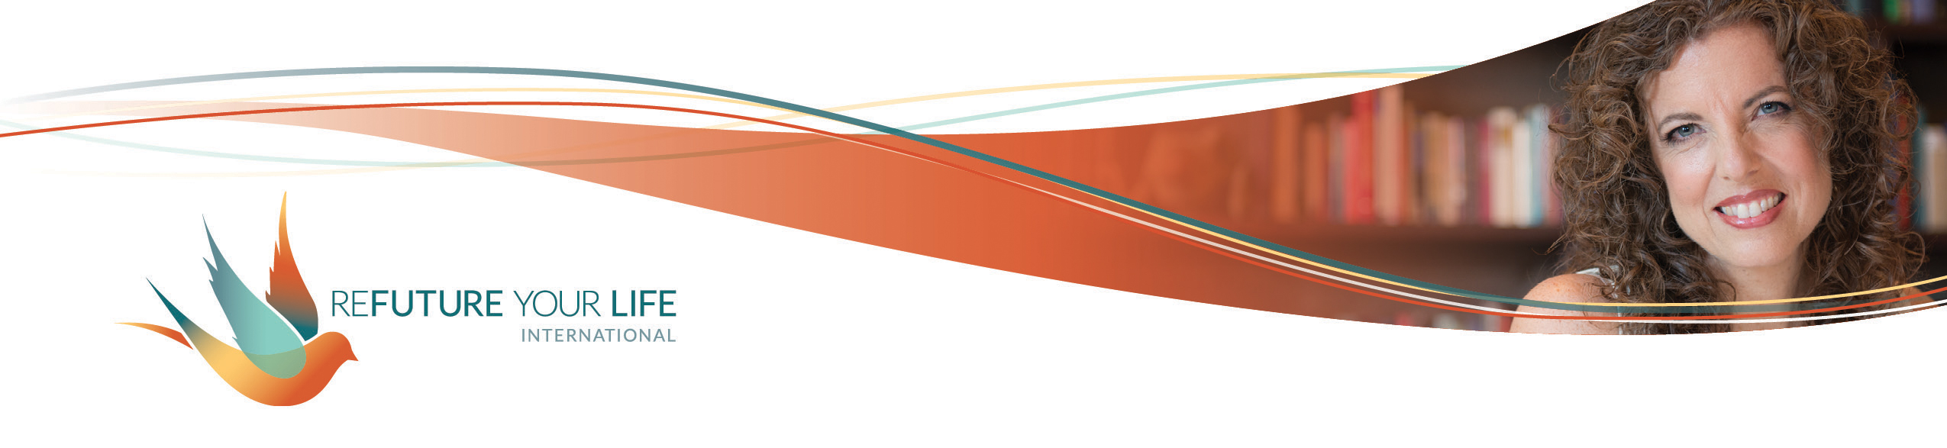

Celebrations and Deep Integration

At this time of the year, with the long, dark days and cold weather, and the high holy days from so many traditions, there’s a profound calling to turn inward. This is, after all, winter.

In ritual, as we look at the year, winter is a time of death and darkness. A time of deep stillness and silence. But like in the yin/yang symbol, within death is the spark of new life. In the darkness, there is a ray of light. In the stillness, a quiet voice is heard.

When we take the time to integrate the energies of the year, to digest what we’ve taken in, we nourish ourselves at deep levels. Like fields that rest over the winter, we’ll be ready for the gentle tendrils of new life visibly emerging in the spring, and the vigorous growth of summer.

Of course, you may personally be experiencing energies of another season. You may be in a time of birth, the excitement of summer, or the harvesting of fall. If so, honor that, along with honoring the overarching energy of winter.

There’s also the fact that many traditions that have emerged in the American culture for this time of year – holiday parties, bright lights and shopping for gifts – can pull us out of our reverie. By all means follow what brings joy to your heart and soul, and I invite you to spend some time in quiet reflection as well.

In the section below, you’re invited to list accomplishments from the year, broken down into a couple of different categories to help you see celebrations that might not otherwise come to mind. Remember that the “small” things can be some of the most meaningful and impactful.

As you think about these celebrations, notice any inner resistance. Is there something in you that says things like:

* Yeah, but _________.
* I’m not going to write that one. It sounds silly.
* I didn’t do that much.
* Everyone else probably has way more that they’ve done.
* I’m still not where I thought I would be by now.
* I can’t write all this big stuff! It’s going to sound like I’m bragging.
* Other people will feel bad if they see my list this year.

You might notice something in your body like tension in your jaw or shoulders, nausea in your solar plexus, a hollowness in your lower belly. Or maybe your mind just feels blank and your body feels numb.

All of that’s okay. Acknowledge it, and write it down in the section for “What I’m noticing in my bodymind”. We’ll address it on the call. Just smile at those thoughts, say an inner “I see you”, and go back to your lists. A dance or stretch break might help, too. If it feels bigger than that and doesn’t feel integrated after our call, reach out to me

I’m also including a section where you can list anything that feels heavy on your heart from this year. It’s important to honor and grieve those things, too. This isn’t about “amping up your energy”. That will likely happen, but it will come from integrating and grounding what you’ve experienced, and returning to your natural essence, not from getting high on endorphins only to crash later.

Okay, ready to do some exploring? Let’s go!

I’m not providing lines for this section, because you’ll likely have way more to write/type than will fit in the normal space. If you attended the Empower Your Awesome virtual retreat, you might want to use the lists you made then as a starting point. Or you might want to start fresh. So many options. ☺

**Accomplishments, celebrations and gratitudes**

1. My accomplishments from this year.
2. My accomplishments from this year in my relationships.
3. My accomplishments from this year in my business.
4. My accomplishments from this year in my health (physical, mental and emotional).
5. Things I tried or did that scared me.
6. Things I’m doing way less or not doing at all.
7. Ways I’ve grown.
8. What I’m grateful for.
9. What’s brought me pleasure this year.
10. What’s been especially meaningful to me this year.

*What I’m noticing in my bodymind as I reflect on all of this:*

______________________________________________________________________

______________________________________________________________________

______________________________________________________________________

______________________________________________________________________

______________________________________________________________________

*Anything that feels heavy or that I want to grieve from the year:*

______________________________________________________________________

______________________________________________________________________

______________________________________________________________________

______________________________________________________________________

*Anything else I want to note or include:*

______________________________________________________________________

______________________________________________________________________

______________________________________________________________________

______________________________________________________________________

*An identity, quality or way of being* that supports me in accepting and integrating this previous year:*

______________________________________________________________________

*Examples: Queen/Sovereign of Energy, inner Goddess/Goddex, Divinity of Love, strong, courageous, empowered, freedom to be myself