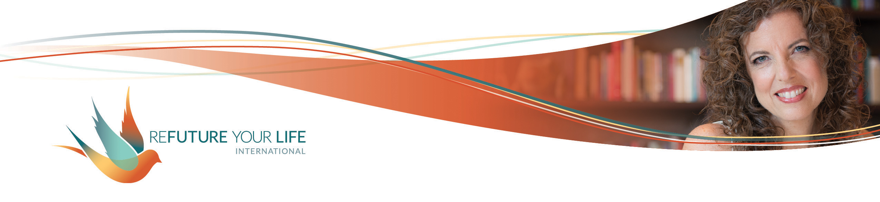

Creating a Vision Video

You’ve likely heard of making a vision board by clipping images and words from magazines that represent what you want to manifest in your life. Images of people you want to study or collaborate with, places you want to vacation or live, etc.

This month, we’re taking that to a whole new level by creating vision videos. We’re doing this for several reasons.

**The process of choosing what to include in your video brings you clarity.** This is important because clarity creates intention, and intention is a powerful guiding force. Without clarity, no real momentum or movement happens in your life. This isn’t about trying to control life or force something specific to happen. It’s more like trying on clothes and seeing what fits you, what feels good and makes you feel energized and alive. **Then, you move in that direction.**

Part of the clarity is seeing where you’re thinking and dreaming small. Where do you want to stretch and dream bigger? What comes up for you when you consider new possibilities for yourself and your life?

**Another reason we’re doing this is to acclimate your nervous system to this bigger version of your life.** One of the main reasons we don’t accomplish our dreams is that some part of us thinks we’ll get hurt or die if we get this thing we want. Studies have shown that the brain doesn’t distinguish between what you’ve actually experienced and what you’ve richly imagined (remember this if you find yourself catastrophizing). By making this vision as real as possible, your nervous system gets the message that you can have this and survive. You’ll now be much calmer as you take steps towards this new reality. (Using soothing or upbeat music will do a great deal towards calming your nervous system.)

**Thirdly, by using sensory input and letting yourself *feel* your desire, you activate the limbic and primal parts of the brain.** This helps your whole system align with the fulfillment of your desires, getting all (or most) of you on board. By easing inner struggles and getting your energy focused in the same direction, taking action toward your desires and the manifestation of them becomes easier and easier. This is where a vision video goes one (or many) steps beyond a vision board. *The more you can put yourself into the vision, the more readily it’s created in your life.* Activating as many senses as you can enables this.

With visioning exercises like this, I like to conclude with the thought, “All of this or something even better for me.” It reminds me not to be attached to the specifics, or to hold on tightly to my wants. It also invites the Universe to bring me things I don’t even realize I desire.

**Logistics**

You can use iMovie, Canva, or any number of other online services to create your movie. You can also find video clips, images, audio clips, etc. online.

If you want to share your video with others, please be aware of copyright rules. To share with the group, you can post your video in the Facebook group or send it via Dropbox, Google Drive, or WeTransfer.

Feel free to use your own images. Years ago, I took a screenshot of my bank’s website page showing my account balances, and then used Photoshop to show more inspiring numbers. ☺

***We’ll use our call this Tuesday to work on the videos and to share ideas and sources. We’ll use the call on 6/15 to do a clearing of the S.T.U.F.F. and if we have time, to share videos (if you want to share yours).***

Remember:

* **You’re going for a stretch, not a splatter.** You want to dream bigger, not freak out your nervous system. Plus, I’ve worked with people who were fine with having a $1,000,000 business, but not with having a $200,000 business on the way there. They were in rescue-me mode, waiting for someone like Oprah to drop a fully-filled clientele in their laps. Where is a discomfort point? Try putting in positive images about *that.*
* Try to **include as much sensory input as possible.** Are there sounds you want to include, like ocean waves, applause, or someone saying “I love you”? Are there video clips that invoke your sense of touch, taste or smell?
* **Include upbeat or soothing music.**
* **You can also use a recording of your voice making “I am” statements or describing your vision. “**I’m a successful business owner. I lead workshops in beautiful places like Costa Rica and Hawaii. My clients are amazing and love the results they get from working with me. Giving myself exquisite self-care with regular massages supports my creativity and the level of service I provide.”
* **Don’t try to include everything.** If you find yourself worrying that you need to cover every single aspect of your life or it won’t change, recognize that as a lack mindset. Put it down as part of your S.T.U.F.F. **Trust your intuition of what to include and what to leave out.**
* **Have fun with this!!** If it starts to feel heavy or like a chore, stop. Take a break. Dance. Move your body. Power pose. Shake. Eat. Rest. Come back to it when you feel energized and ready.

As you create your video, notice what comes up. What images make you feel uncomfortable or embarrassed? What feels especially good? This is what we’ll be working with on our Clearing Call.

*My S.T.U.F.F. that came up:*

_____________________________________________________________________

______________________________________________________________________

______________________________________________________________________

______________________________________________________________________

______________________________________________________________________

______________________________________________________________________

______________________________________________________________________

*What excites me the most about my video:*

______________________________________________________________________

______________________________________________________________________

______________________________________________________________________

______________________________________________________________________

______________________________________________________________________

______________________________________________________________________

______________________________________________________________________