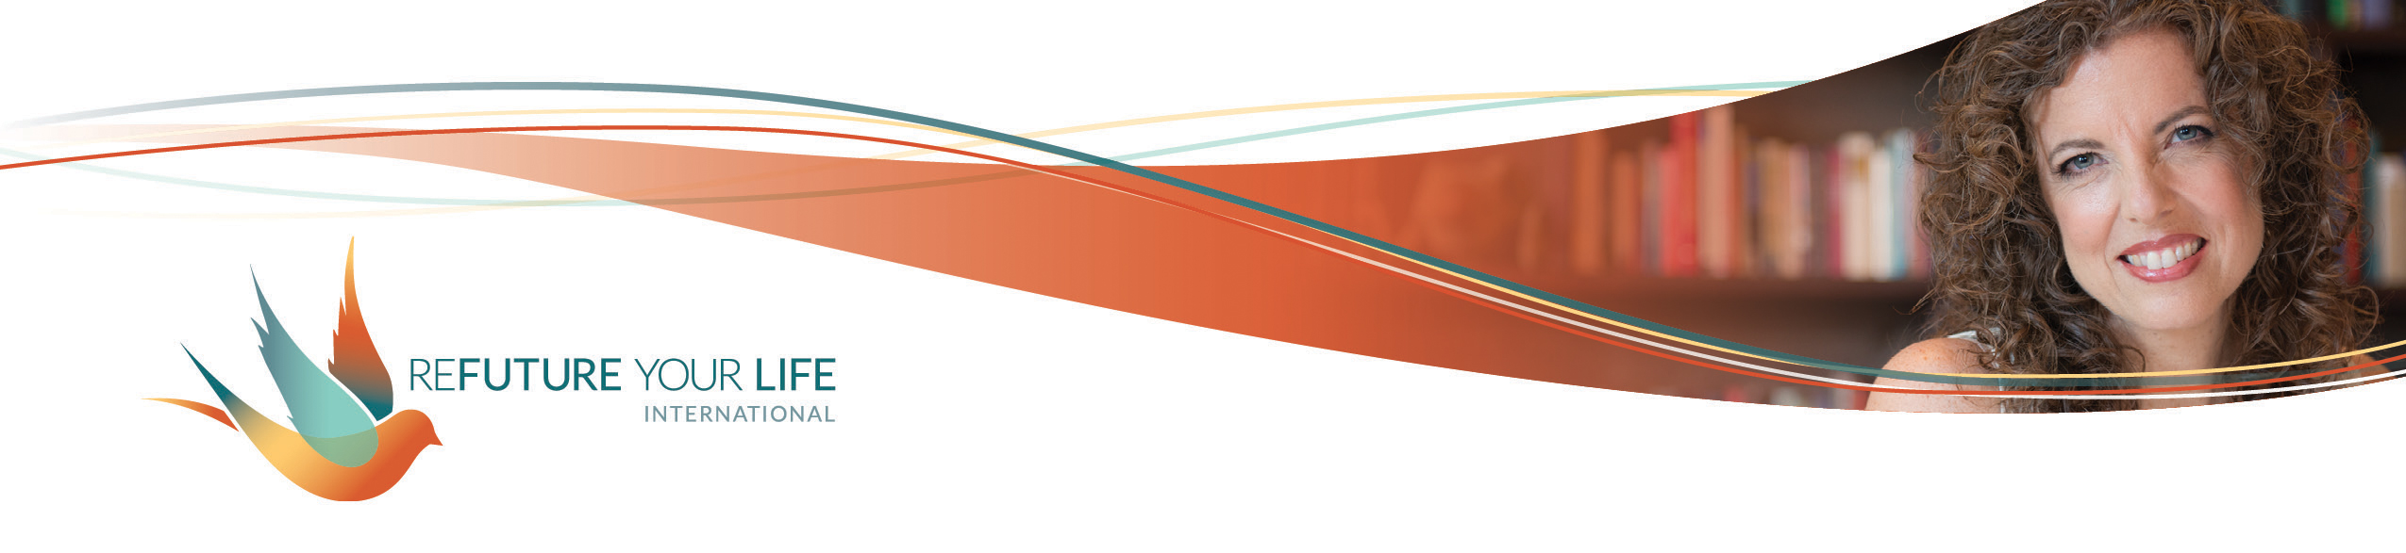

**Curiosity**

Curiosity is such a powerful tool. It opens the way for creativity, innovation and change. It can also bring a deeper level of connection to yourself, another person, and/or your work. It can feel spacious, gentle, exciting, playful and energizing.

**Curiosity can also feel very vulnerable.** Being curious means lowering defense shields – there has to be an opening for something new to come in. It means giving up preconceived ideas and standard ways of thinking and behaving. It therefore carries an element of uncertainty, which is extremely uncomfortable for some people. It requires letting go of being right (at least temporarily).

Curiosity is magical because you don’t know where it’ll lead you. It invites imagination and venturing into unknown territory. You can get curious about a situation, about another person, or about yourself, including your past, present and future.

Leaders use curiosity to engage others, creatively problem-solve, and inspire innovation. Autocrats use blame, deflection and rules to maintain control (or at least the illusion of it). **When you feel stuck with anything, curiosity can be a *great* asset, opening the way to new possibilities and outcomes.**

**The opposite of curiosity is *knowing.***When we think we know what will happen or what the other person will do, we close down ingenuity and creativity. We lock the other person into a box of how we *know* they’ll act or what we *know* they’re thinking. This in turn locks *us* into a box in our interactions with them. This is a big reason we can feel stuck.

You may unintentionally be sabotaging your curiosity and limiting your possibilities by:

* **Trying to get an answer, especially if you’re looking for a *right* answer.** Curiosity invites imagination and creates space for your intuition to be heard. The energy of trying, “have to”, rules and agendas closes down that space.
* **Wanting to be *right*.** This requires that you hold onto a particular point of view or outcome. This win-lose perspective locks you into a set vision and limits your options.
* **Believing you already know what will happen or that you’re already defeated.** Curiosity requires you to at least entertain the possibility that you’ll have a new insight or that something can change.

When getting curious, be aware that asking yourself ***why*** can keep you going around in circles. “*Why did this happen? Why did she do that? Why can’t he understand? Why can’t I be different?*” These just aren’t very productive questions.

Instead, ask yourself questions using *what, how and who*. When you feel “done” with a question, try asking yourself, “And what else?”.

* What am I feeling in my body?
* What’s the greatest version of this that I can imagine?
* What’s the greatest outcome that I can imagine?
* Who do I want to be in this situation?
* Who would I be without this? (“This” could be a role, feeling, behavior or identity.)
* How is this situation serving me, just as it is?
* If I were overlooking something here, what might it be?
* What assumptions am I making?
* What might this person be thinking and feeling right now? What might they be scared of? What might they want? What might they want for me?
* Who might be able to help me with this?
* What resources and tools am I overlooking?
* What can I do to bring in a different energy in this moment?
* What are some possibilities for this situation?
* What might be impacting this person’s behavior?
* What do I need in order to feel safe getting curious?
* What might I not be seeing about this?
* What might I not be feeling that’s here for me?
* What are possible deeper meanings for this?
* What is it time for now?
* If I had a magic wand, what would I change, create or remove? What effects would that have?
* What’s wanting to be seen, shared or created now?
* What are my intentions for this?

The more lightly you can hold these questions, the more easily you’ll get new insights and perspectives. Try using these questions as journal prompts and set a timer for 10 minutes. Write continuously for the whole time. Don’t think too much, just write whatever comes to your mind. If you don’t “know the answer”, make something up.

**Think of a situation that you don’t feel satisfied about. Journal using one or more of the questions about and see what insights you get. What do you notice?**

______________________________________________________________________

______________________________________________________________________

______________________________________________________________________

______________________________________________________________________

______________________________________________________________________

**Let’s get curious about what we want to create! Here are some questions to play with:**

If I were to imagine the most joyous, expanded version of my life, what would that include?

______________________________________________________________________

______________________________________________________________________

______________________________________________________________________

______________________________________________________________________

What are some things I’m really good at?

______________________________________________________________________

______________________________________________________________________

______________________________________________________________________

______________________________________________________________________

If I were to imagine the most joyous, expanded version of the world emerging from this experience of slowing down, what would that look like?

______________________________________________________________________

______________________________________________________________________

______________________________________________________________________

______________________________________________________________________