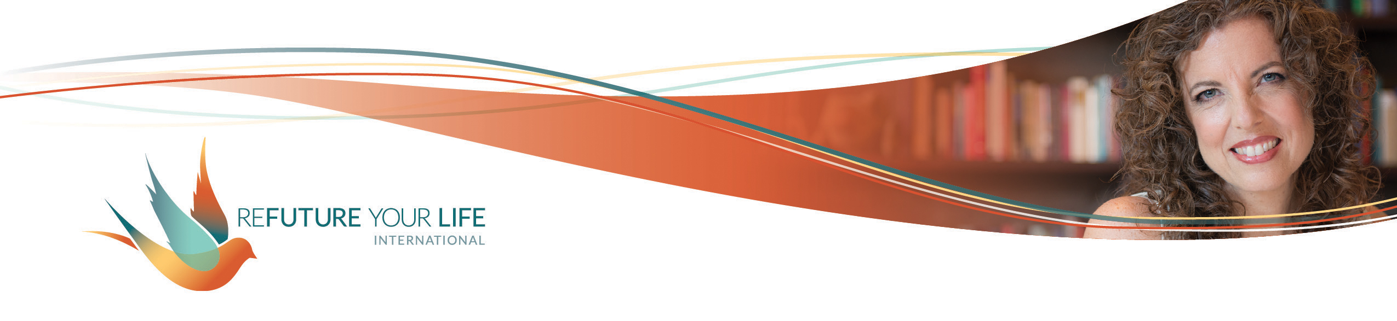

**Integration**

With everything that’s going on in our world right now, we’re being called to slow down, integrate, and connect more deeply with self. So that’s what we’re doing this month.

COVID-19 is showing us very clearly how interconnected we are. We’re seeing that everything we do has ripple effects, and that we’re connected with those across the world through the air we breathe and the objects we touch. We see how our choices affect so very many others.

Even more than that, we see that we’re connected through the similar experiences of loneliness, of loss and grief, of supporting the healthcare workers and those in the trenches, of wanting to connect with loved ones, and so much more.

This is a time of great fear and great love. Of isolation and deep connection. It is a time of possibilities.

In all of this, your connection with yourself is your keel and rudder. On a sailboat, the keel is a flat blade that extends below the hull (bottom of the boat) down into the water. It keeps the boat on course as it counterbalances the thrust of the wind, and helps propel the boat forward. It also keeps it upright in strong winds.

Likewise, your connection with yourself keeps you steady with the winds of fear flow around you, when you feel buffeted by others’ desires and agendas, and when your own S.T.U.F.F. swirls around inside you.

Your connection with yourself is also your connection with the Universe and All That Is. It’s both grounding and freeing, focused and expansive.

Deeping this connection – and expressing that connection in the world – is the work and adventure of a lifetime. It’s truly what owning your power and expanding your life is all about.

This month, we’re pausing to do any cleanup of the corners that might be needed. You know how, when you clean out a closet and get all the big stuff out, it makes a huge difference. Then, if you take the time to vacuum the floor, clean out the corners and wipe down the shelves, it gleams. It may not be as easy to spot the changes, but there’s a deep sense of satisfaction and rightness. That’s what we’re doing this month.

I invite you to look back over the past months’ topics and see what gets your attention. Where would you like to do a little bit deeper work? What’s still niggling at you?

Alternatively, look and see what comes up for you when you envision this deeper connection with yourself. Is there a fear, a longing, a dream that’s getting your attention?

On our clearing call, we’ll do a clearing process, and then we’ll spend time each connecting with ourselves. It will be a time of inspiration, too.

As you prepare for this, see what comes up with these prompts.

A past topic that I want to go deeper with is ___________________________________

When I imagine connecting with myself more deeply, I feel _______________________

______________________________________________________________________

______________________________________________________________________

When I imagine connecting with myself more deeply, I notice this in my body: ________

______________________________________________________________________

______________________________________________________________________

When I imagine connecting with myself more deeply, I worry that __________________

______________________________________________________________________

______________________________________________________________________

When I imagine connecting with myself more deeply, my greatest desire is __________

______________________________________________________________________

______________________________________________________________________

If anything’s in the way of more deeply connecting with myself, it’s _________________

______________________________________________________________________

______________________________________________________________________