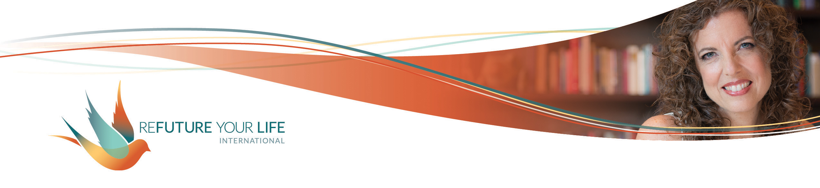

**Taking Responsibility**

Many of us have a lot of baggage around the word “responsibility”. Often, parents use it as a way to get kids to do what reflects well on the parents, or what the parents think will help the child be successful in life. Sometimes it’s used in a much more coercive or manipulative way.

Responsibility can carry the weight of so many shoulds and shouldn’ts. Expectations (or our perceived expectations) from our family, friends, society, culture, etc. can weigh very heavily on us. We may not even realize how much we’re being molded by what we think a “good” daughter / mother / partner / person / business owner does.

There’s a very different and more empowering lens through which we can see it.

You may have heard the saying that responsibility is the ability to respond. Responding to something is very different from reacting to it. Responding means that you’re being creative and are making choices. It involves a level of awareness and self-direction that’s not present in merely responding.

The follow-up question I haven’t heard asked is “**What are you responding *to?***”

**When we’re being mindful, we respond both to what Life brings us, and what our soul is longing for**. Our choices become a dance between the two. Rather than following some outer dictate and being responsible to others, **we become responsible to and for ourselves.** Often, feeling stuck is a sign that we’re struggling between the two.

Being responsible to and for ourselves is an act of courage. Sometimes we risk the anger and disapproval of others. It might seem easier to do what’s expected of us, but then we betray ourselves. Those betrayals can eat away at our soul, our joy, and our sense of our own power.

The big thing to keep in mind is that our soul longs to express our gifts in the world, to create what we’re here to create. **Our soul’s expression is always an expression of love.** When we’re responsible to and for ourselves, we create a vibrant, connected life that makes a difference in the world. Instead of doing things – even things like exercise and eating well – from a place of “should”, we do them from a loving space of being responsible to ourselves for working toward our goals.

Becoming truly responsible to and for ourselves is a process. It’ll shine a light on every place where you’re still tied into the shoulds and others’ expectations. You’ll recognize them from the feelings of guilt. You’ll likely notice a worry about getting into trouble or “making someone mad”. You’ll likely need practice, support and lots of deep breathing as embrace your power in this area. And please remember, **this isn’t about perfection!! It’s about awareness, choice, love and the process of expansion.** Remember to look for ways to make 1% improvements.

Let’s get started.

My “baggage” thoughts about responsibility are ________________________________

______________________________________________________________________

______________________________________________________________________

My specific fears about letting go of “shoulds” and following my heart / soul include ____

______________________________________________________________________

______________________________________________________________________

______________________________________________________________________

When I think about being responsible to and for myself, I feel _____________________

______________________________________________________________________

______________________________________________________________________

One dream or goal I have is _______________________________________________

______________________________________________________________________

Being responsible to and for this goal means that I’d consistently __________________

______________________________________________________________________

______________________________________________________________________

This week, I choose to ___________________________________________________

______________________________________________________________________