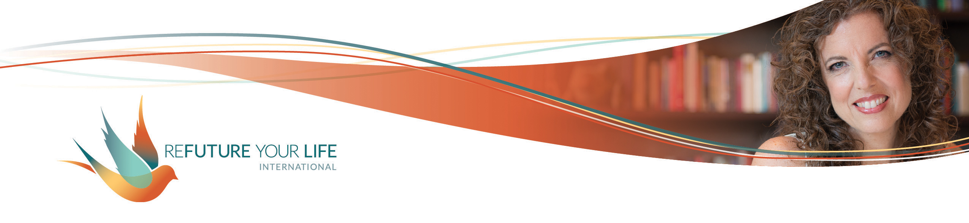

**Addictions, Distractions and Habits**

**(oh my!)**

Did you just groan at this topic? If so, I totally get it. This isn’t what most people would consider a happy, light subject. So before we go any further, I want to be very clear about what this exercise is ***not*** about.

This exercise is ***not*** about:

* guilt
* shame
* shoulds
* judgment
* blame
* perfection
* being wrong
* obligation

This exercise ***is*** about:

* awareness
* choice
* commitment
* self-compassion
* curiosity
* play
* readiness.
* freedom

It’s about building your awareness and your capacity to stay present with what’s happening inside and around you. **It’s about claiming more of your personal power.**

Okay. Are we good?

What we’re looking at this month are activities you engage in regularly that diminish your presence and power. I separate these into habits, distractions and addictions. All three categories involve a degree of unconsciousness, of separation from your feelings and life as it’s happening in the moment. The primary difference is in the degree of separation, and in the intensity of connection with the behavior itself.

Here’s how I define them.

**A habit is something you do regularly without a lot of emotional attachment to it.** Like brushing your teeth or exercising, some habits increase your well-being. Others deplete your energy. We’re focusing here on the latter kind.

**A distraction tends to be a temporary way of letting off steam or reducing the intensity of a situation.** Sometimes that’s exactly what’s needed. Sometimes, though, the intensity is leading you toward a transformation of something heavy into something light. It may be an opportunity to process and integrate something from your past. It’s a chance to expand your capacity to feel and be with your own energy and power.

**An addiction is a behavior to which you’re very attached.** There are strong energetic and emotional ties to it. Thinking of not engaging in the behavior can bring up anxiety and overwhelm.

The behaviors in these categories can be to *anything* – alcohol, exercise, logical thinking, emotional overwhelm. It’s whatever is your stuck way of interacting with yourself and your world.

In the vast majority of cases, a behavior isn’t good or bad. Watching TV can be a habit, distraction or addiction. It can also be an act of self-care, connection with someone else, and/or expansion of your world-view.

**It’s important to remember that these behaviors have served you.** They’ve enabled you to keep moving forward, to handle whatever has felt too intense. They’ve allowed you to relieve some of the inner pressure so that you felt safe.

These behaviors can be a lot like a scab that’s formed over a wound. It may not be time for the scab to come off yet. There may be underlying healing that needs to happen first. On the other hand, a scab that stays on too long is restrictive. It’s a barrier between the healthy tissue and air, light and touch.

It’s up to you to decide if a behavior is ready to be removed or not. So before you start, **give yourself permission to notice a behavior and *not do anything about it*.** You get to do what’s right for you. You are not obligated to change something that you’re not ready to change.

As you identify and consider a behavior, stay curious. Let yourself feel the initial emotions that come up and see what’s below that. It may be time to loosen or remove a behavior. It may be time to bring light to what’s underneath it and let that be enough for now. It may be that there’s something you want to set aside and do on a one-on-one call. As always, ***do what’s right for you*, and be willing to get curious to see what that is.**

If you feel stuck on any of the questions, just make something up. Write whatever pops in your mind, as if you know what you’re talking about.

If you feel drawn to really delve into this and take time with it, go for it. If you jot down a few words for each question, that’s fine, too. This doesn’t have to be heavy. It’s about building your awareness and your capacity to stay present.

Ready?

**Write down no more than 2 behaviors for each category**. If you want to stick with one overall (not even one per category), that’s fine, too.

Habit(s) _______________________________________________________________

Distraction(s) ___________________________________________________________

Addiction(s) ____________________________________________________________

The behavior I’m going to focus on this month is: ______________________________

I’m most likely to engage in this behavior when ________________________________

______________________________________________________________________

______________________________________________________________________

A typical scenario is _____________________________________________________

______________________________________________________________________

______________________________________________________________________

When I engage in this behavior, I feel _______________________________________

______________________________________________________________________

______________________________________________________________________

This behavior helps me avoid ______________________________________________

______________________________________________________________________

______________________________________________________________________

This behavior helps me ___________________________________________________

______________________________________________________________________

______________________________________________________________________

The child in me wants/needs ______________________________________________

______________________________________________________________________

______________________________________________________________________

I’m scared / worried / nervous ______________________________________________

______________________________________________________________________

______________________________________________________________________

The possibility I see for myself related to this is ________________________________

______________________________________________________________________

______________________________________________________________________

I’m grateful for/that ______________________________________________________

______________________________________________________________________

______________________________________________________________________