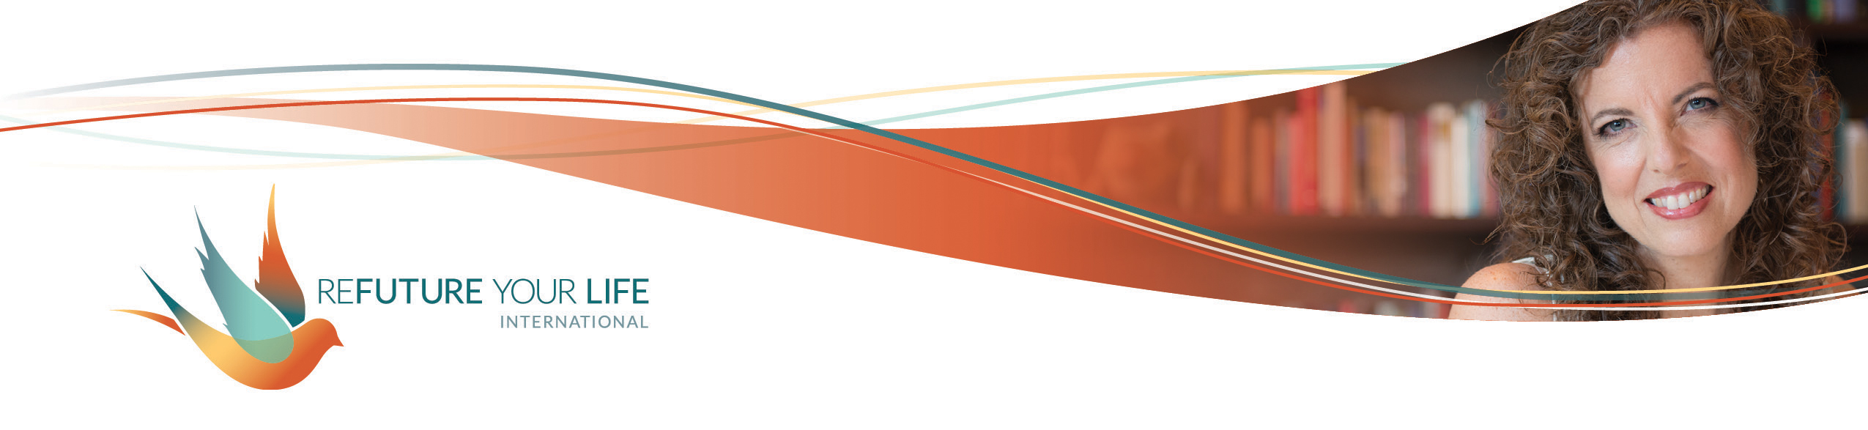

Clearing the Way for and Inviting Magic

We’re here at the end of the year in the dark days of winter, at least here in the Northern Hemisphere. While it can feel dark and dreary, it’s a very magical time. We’re called to go within so that we can find and share our light in a new way. It’s a time to prepare for the birth of the new year, and in some ways a new us. The following questions will help guide you in this.

We’ll start by releasing old patterns and habits. Remember, habits and old patterns that feel counterproductive and maybe even shameful have served you in some way. If you needed crutches to support you while a leg injury healed, would you hate the crutches? Imagine the energetic contortion that would create. And, once the injury healed, think of how continuing to use the crutches would hold you back and keep you from running, jumping and dancing.

You’ve done SO much healing and expanding this year. Let’s take this time to see what crutches it’s time to release – with love and gratitude. Just like if you’d been using physical crutches, you may feel shaky, nervous and even scared to let go of your emotional and energetic crutches. There may even be a weaning process, and that’s okay. The key, as always, is to be aware and to make conscious choices. And not to judge or shame yourself if you use the crutches again. Just keep practicing your steps.

When responding to the prompts below, keep in mind that you want to stretch, not splatter. This isn’t about “fixing” you because you aren’t broken. This isn’t about dropping support that you still need for your healing and expansion. This is an opportunity to look at yourself and your patterns with love, awareness and clarity, to play with possibilities, and to make conscious choices.

There’s a Chinese tradition that before New Year’s (usually in February), everything is taken out of the home. The home is cleaned and painted, then what is wanted is put back in. Anything that needs to be repaired is repaired. Anything that isn’t wanted or used is given or thrown away. If you’d like, take that energy with you as you respond below.

Letting go of what doesn’t serve us and stretching into what we consciously choose clears the way for magic and alignment. Marking times of transitions (like into a new year) shakes and wakes us. Being cognizant of the cycles in life, in *our* lives, and in our beingness is critical for our expansion and delight. It allows us to celebrate and recalibrate. My friends, we’re building new neural pathways. We’re creating new habits and increasing our capacity to hold more energy, more joy, and more love. And we’re raising the bar by doing it together and harnessing the power of group energy and intention.

Ready to take your next step?

Don’t feel like you need to fill the spaces provided. If you have one thing to write, that’s fine. This isn’t about quantity or comparison. Honor your inner wisdom and your heart.

With love and deep gratitude for the ways they’ve helped me feel safe and able to cope with life, I choose to release the following habits, thoughts and patterns:

______________________________________________________________________

______________________________________________________________________

______________________________________________________________________

______________________________________________________________________

______________________________________________________________________

Ways in which I have stretched this year and things that I’m proud of myself for:

______________________________________________________________________

______________________________________________________________________

______________________________________________________________________

______________________________________________________________________

______________________________________________________________________

______________________________________________________________________

______________________________________________________________________

Ways in which I choose to stretch in the coming year:

______________________________________________________________________

______________________________________________________________________

______________________________________________________________________

______________________________________________________________________

______________________________________________________________________

A few words that resonate with how I want to be and feel, or the expansion I’m embracing, in the new year are:

______________________________________________________________________

______________________________________________________________________

______________________________________________________________________

The word that most deeply resonates

for me personally: ______________________________

for my business: ______________________________

This is known as your word of the year (WOTY). We’ll work with this on our Clearing Call.

In the coming year, I want to remember that:

______________________________________________________________________

______________________________________________________________________

______________________________________________________________________