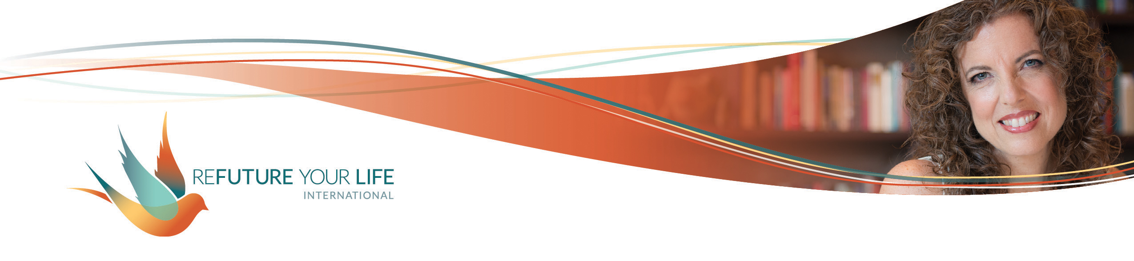

Going Deeper with Enoughness

We’re taking this month to go deeper with the feeling of enoughness. Take a look at what you’re experiencing in your life. Where are you not feeling like enough? Where do you feel like you don’t have enough? That is your Area of Exploration (AOE) for this month. It could relate to a specific project with work, something more general like abundance, or a role you have, like mother / daughter / partner.

What is your AOE for the month? ____________________________________

What S.T.U.F.F. (Stuck Thoughts, Unresolved Feelings and Fears) do you notice when you think about your AOE?

______________________________________________________________________

______________________________________________________________________

______________________________________________________________________

______________________________________________________________________

______________________________________________________________________

What would it look like if you were rocking your AOE?

______________________________________________________________________

______________________________________________________________________

______________________________________________________________________

______________________________________________________________________

______________________________________________________________________

What would failure look like?

______________________________________________________________________

______________________________________________________________________

______________________________________________________________________

______________________________________________________________________

______________________________________________________________________

Now, relax your shoulders, take a deep breath, and do either the head or the heart-center pose as you something like the following to the part of you that’s feeling scared about all of this:

I feel how scared you are. I know that you don’t feel like you’re enough for this, that you’re good enough (abundant enough, etc.). What if it’s possible that you’re doing the best you know to do right now. What if it’s possible that you’re doing better than you realize. I love you. [Or, I want to love you.] I look forward to doing the Clearing Call on behalf of both of us.