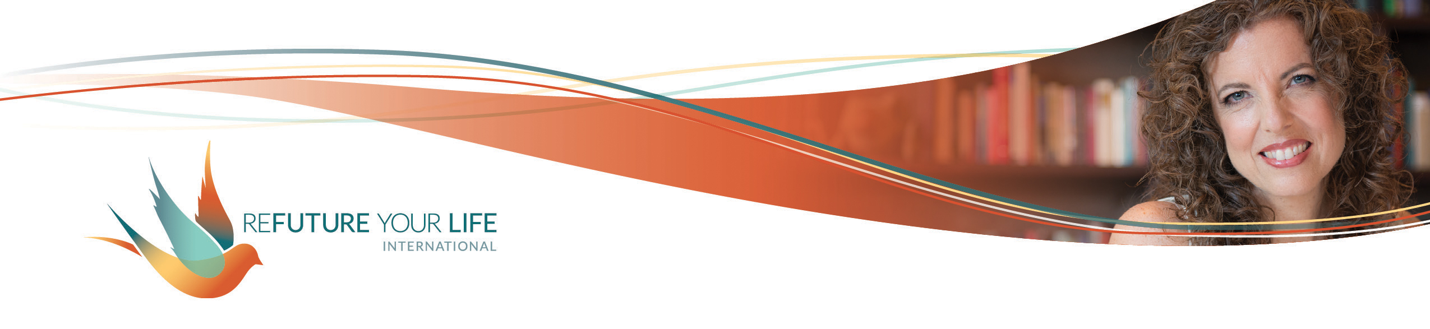

**Uncovering Your Enoughness**

This month, we’re looking at the messages and experiences that have separated you from your deep knowing, in your cells, that you are truly enough, just as you are.

Breathe that in for a moment. What if it’s possible that you are truly enough, just as you are. What if it’s possible for you to know in every fiber of your being that you are truly enough, just as you are.

I’ve been excited to cover this topic with you, as I’ve been working on it myself. The other day, I did a chakra meditation and clearing for myself sitting with the message of enoughness in each chakra. It felt deep and rich.

As often happens, life has handed me a few days of situations so that I could *experience* my connection with my feeling enough. Most have involved family situations where in the past I would question my enoughness. This go around, I kept coming back to knowing that I’m enough. Knowing that I can have made mistakes, and still be enough. I can see things I could have done better for sure, and still be enough. I can know that I’m enough and stay present with someone who’s angry, withdrawn or disappointed.

Another experience was on the other end of the spectrum – receiving at a deeper level and in ways I haven’t before. This showed me that we have to trust in our own enoughness to generously receive. In the past, I would have tried to not take so much out of fear of taking *too* much. I’d have started trying to give back before the person was complete in the giving, robbing the other person of their full expression in the giving.

Be on the lookout this week as you get ready for the clearing call. Where are old messages about enoughness showing up in your life and your self-talk, whether they’re about being/doing/having/asking too much *or* too little? We’ll do some excavating here to bring things up to be released.

You also notice things coming up as you move through your days, too. You can write them down, or you can imagine putting them into a group container for our call. They’ll be there waiting for the clearing call.

What messages did you get as a child about wanting / needing / asking / being / having / doing too much or too little?

______________________________________________________________________

______________________________________________________________________

______________________________________________________________________

______________________________________________________________________

What comes up for you about wanting / needing / asking / being / having / doing too much or too little in regards to money?

______________________________________________________________________

______________________________________________________________________

______________________________________________________________________

______________________________________________________________________

What comes up for you about wanting / needing / asking / being / having / doing too much or too little in regards to relationships?

______________________________________________________________________

______________________________________________________________________

______________________________________________________________________

______________________________________________________________________

If you knew in every fiber of your being that you’re enough, what in your life would be different?

______________________________________________________________________

______________________________________________________________________

______________________________________________________________________

______________________________________________________________________

If you knew in every fiber of your being that you’re enough, how would you treat yourself?

______________________________________________________________________

______________________________________________________________________

______________________________________________________________________

______________________________________________________________________

What messages about your enoughness would you love to tell your child-self and/or your current self?

______________________________________________________________________

______________________________________________________________________

______________________________________________________________________

______________________________________________________________________

______________________________________________________________________

______________________________________________________________________

To share your responses, and to see what others have said, go to <https://forms.gle/rvzKEiFjSdPoyFZN7>.