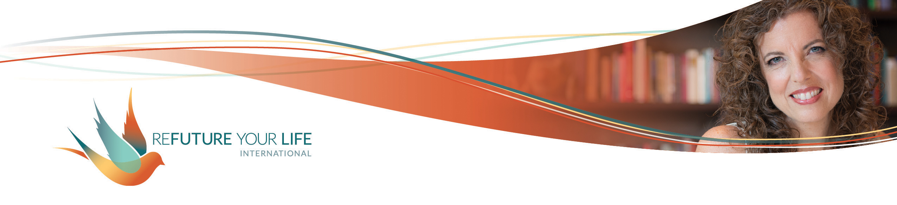

**Exploring Vulnerability**

I think it’s clear that I go deep in my work with groups. ☺ It’s because I go deep in my work with myself. My intention and commitment is that the work we do together makes a difference in your life. Increasing your ability to be vulnerable will do that.

What’s also true is that these topics don’t come from my mind or an agenda. I get guidance from Love on where to take us next. Sometimes Love speaks through something someone mentions in a conversation, or that I read in a book, or hear in a song, and I always recognize it when it arrives. Often it comes with a full outline of what to talk about related to the topic.

This time, it came through deep meditation, with tenderness and strength. It came as only a word and no other information, requiring me to be vulnerable and to simply show up without the “protection” of preconceived ideas or outlines.

Contrary as it may seem when so many in our world focus on outer power and shows of might, **vulnerability is the pathway to our greatest power and creativity. It creates true connection, both with ourselves and others.**

Vulnerability shows up in our words and how much we share of ourselves. Speaking up when we feel vulnerable takes courage. Often what gets us over the hump to use our voices is a commitment we have. We may be deeply committed to our own expansion or to honesty in a relationship. **Our ability to be vulnerable opens up so many possibilities that don’t exist when we stay closed and armored.**

While we usually think of vulnerability related to what we say, **silence – both with ourselves and others – can also be very vulnerable.** We often feel an urge to talk in those moments (or turn on something to listen to) because the silence feels uncomfortable. We might feel naked and unprotected, unsure of what will happen next. Being able to feel uncomfortable and vulnerable, and stay quiet, allows time for what’s below the surface to emerge.

Very often, our sense of vulnerability is closely tied to areas where we’ve experienced shame. If you find shame coming up as you consider your areas of vulnerability, listen to the recording of the Clearing Call for shame and work through the processes there. Remember that you are held in the energy of the group, and that you can schedule a one-on-one call with me.

Let’s look more closely at vulnerability and the experiences with it that you want to bring to our Clearing Call.

Being able to recognize what vulnerability feels like physically will help you recognize it and make a conscious choice about moving into it or not. Think of a time that you felt vulnerable. What were you feeling in your body?

_____________________________________________________________________

_____________________________________________________________________

What are situations where you typically feel vulnerable?

_____________________________________________________________________

_____________________________________________________________________

_____________________________________________________________________

_____________________________________________________________________

_____________________________________________________________________

_____________________________________________________________________

_____________________________________________________________________

What does your Safety Self say (or worry about) when you have a chance to be vulnerable? What are the old messages you have about being vulnerable? If you can think of a specific situation, you might discover some very specific old messages around what you can and can’t have / be / do.

_____________________________________________________________________

_____________________________________________________________________

_____________________________________________________________________

_____________________________________________________________________

_____________________________________________________________________

_____________________________________________________________________

_____________________________________________________________________

What are your commitments or goals that inspire you step into vulnerability even when you feel nervous or scared?

_____________________________________________________________________

_____________________________________________________________________

_____________________________________________________________________

_____________________________________________________________________

_____________________________________________________________________

_____________________________________________________________________

What is one time (or more) when being vulnerable led to something positive or transformative for you?

_____________________________________________________________________

_____________________________________________________________________

_____________________________________________________________________

_____________________________________________________________________

_____________________________________________________________________

_____________________________________________________________________

_____________________________________________________________________

Congratulations! By raising your awareness this way, you’re accessing more of your power. Join me for the Clearing Call (or listen to the recording) for vulnerability to go even further. We’ll release some of your old experiences with and messages about vulnerability, making it even easier for you to step into this powerful way of being.